**Track** (**AM/SM/AF/AI/BD/DM/HR/ID/MT/PR/SD/SE/EG/TD/TL/RD): AM**

Ratiometric detection of Zn2+ and Cd2+ ions by a benzobisimidazole based probe in triple solvent systems

Araghni Bhattacharya, Vadivelu Manivannan*

Department of Chemistry, Indian Institute of Technology Guwahati, Assam, India.

aragh176122036@iitg.ac.in.

*Corresponding author, Email: mani@iitg.ac.in

Chemo-sensing specifically by colorimetric and fluorometric methods are fascinating field of interest for many researchers due to its versatile form of uses, cost-effectiveness and easy methodology. In fluorogenic chemo-sensing probe, ratiometric detection of analytes is of great interest as the fluorescence emission maximum of the probe changes gradually from certain wavelength to another wavelength thereby changing the colour of the fluorescence emission. Benzobisimidazole moiety has been found in tunable fluorescent dyes [1,2], CO2 sensors [3] and preparation of fluorescent metal organic framework [2]. 2,6-Di(2-pyridyl)-1,5-dihydrobenzo[1,2-*d*:4,5-*d*']diimidazole (**L**) obtained from 1,2,4,5-tetraaminobenzene tetrachloride and 2-picolyl amine by reported method [4] got our attention as it could be a potential metal ion(s) sensor. In HEPES buffer/DMSO (1:1, *v/v*, pH = 7.34, rt) **L** has exhibited an absorption maximum at 354 nm along with a shoulder at 370 nm. UV visible spectrum of **L** was recorded in presence of the metal ions *viz.,* Na+, K+, Ca2+, Al3+, Li+, Fe3+, Co2+, Cd2+, Hg2+, Pb2+, Zn2+, Cr3+, Ni2+ and Mn2+ and it was observed that there was shift and/or diminishing of absorbance intensity in presence of Zn2+, Cd2+, Ni2+, Hg2+ and Co2+ ions. Emission spectroscopic study was carried out in HEPES buffer/DMSO (1:1, *v/v,* pH=7.34, rt), DMSO/deionized water (1:1,*v/v*, rt) and deionized water.The probe itself is a fluorescent molecule as observed under the long UV light lamp, which shows violet fluorescence. Fluorescence titration experiments were conducted in HEPES buffer/DMSO (1:1, *v/v*, pH=7.34, rt), water/DMSO (1:1, *v/v*, rt) and pure water. In HEPES buffer/DMSO (1:1, *v/v*, pH=7.34, rt) and water/DMSO (1:1, *v/v*, rt), free **L** showed emission maximum at 412 nm with λex = 354 nm. Fluorescence spectral characteristics of **L** was analyzed in presence of various metal ions and a red shift (from 412 to 439 nm) was observed only in presence of Zn2+ and Cd2+ ions along with some reduction in the emission intensity. But Ni2+, Co2+ and Hg2+ ions which showed shift in absorption maximum, have quenched the fluorescence intensity. Binding constant of Zn2+ and Cd2+ ions were calculated to be 2.05×103 and 2.29×103 mol lit-1 and stoichiometry to be 1:2 (**L** : metal ion).



**L**

**References**

(1) Boydston, A. J.; Pecinovsky, C. S.; Chao, S. T.; Bielawski, C. W.(2007) Phase-Tunable Fluorophores Based upon Benzobis(Imidazolium) Salts. Journal of American Chemical Society, Vol.129 (47), pp. 14550–14551.

(2) Yin, X.; Song, Y.; Wang, Y.; Zhang, L.; Li, Q. (2014) Synthesis, Structure and Luminescence Properties of Metal-Organic Frameworks Based on Benzo-Bis(Imidazole). Science China Chemistry, vol.57 (1), pp. 135–140.

(3) Guo, Z.; Song, N. R.; Moon, J. H.; Kim, M.; Jun, E. J.; Choi, J.; Lee, J. Y.; Bielawski, C. W.; Sessler, J. L.; Yoon, J.(2012) A Benzobisimidazolium-Based Fluorescent and Colorimetric Chemosensor for CO2. Journal of American Chemical Society Vol.134 (43), pp. 17846–17849.

(4) Andeme Edzang, J.; Chen, Z.; Audi, H.; Canard, G.; Siri, O. (2016**)** Transamination at the Crossroad of the One-Pot Synthesis of N-Substituted Quinonediimines and C-Substituted Benzobisimidazoles. Organic Letter,Vol. 18 (20),pp. 5340–5343.

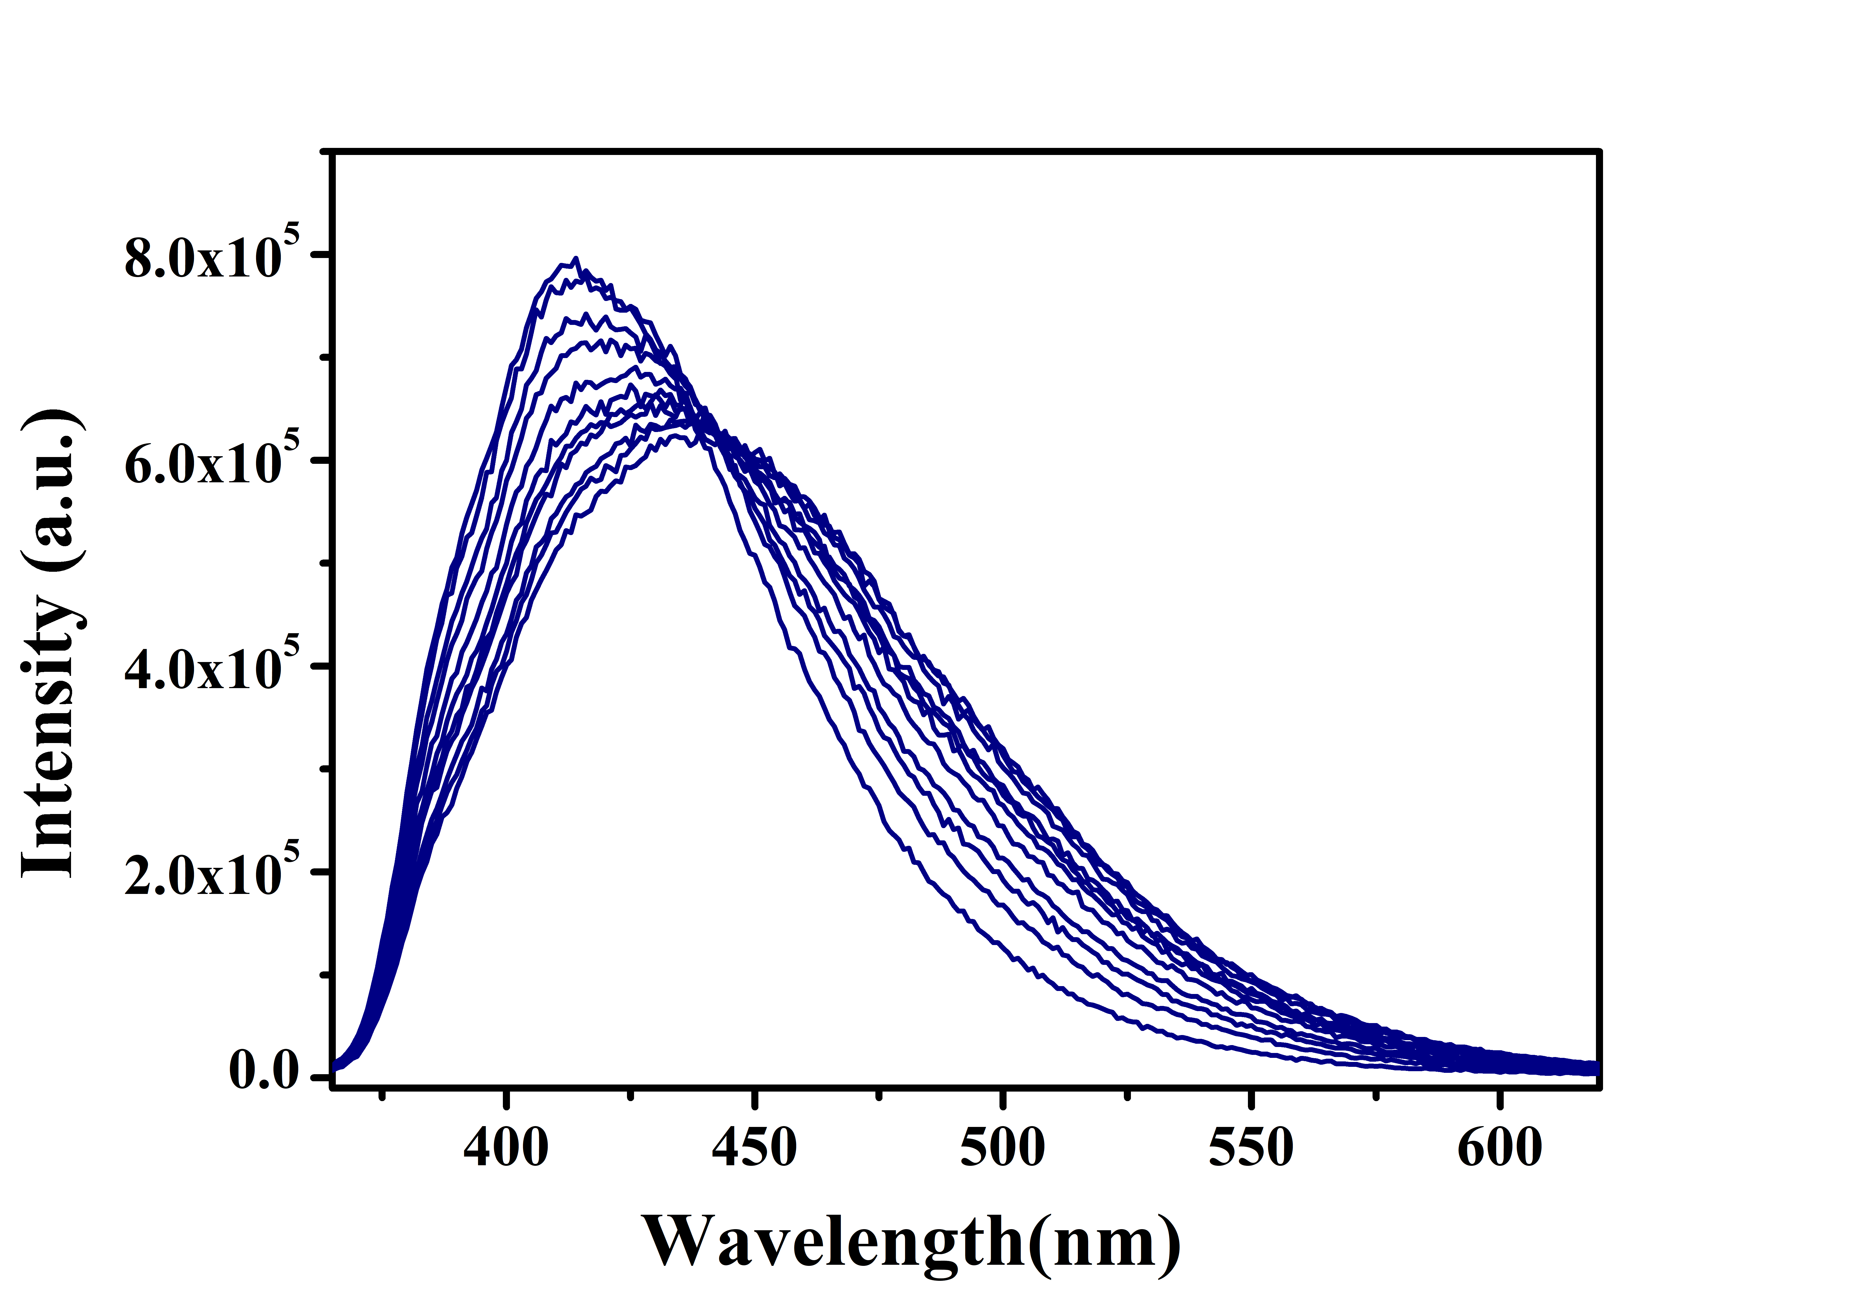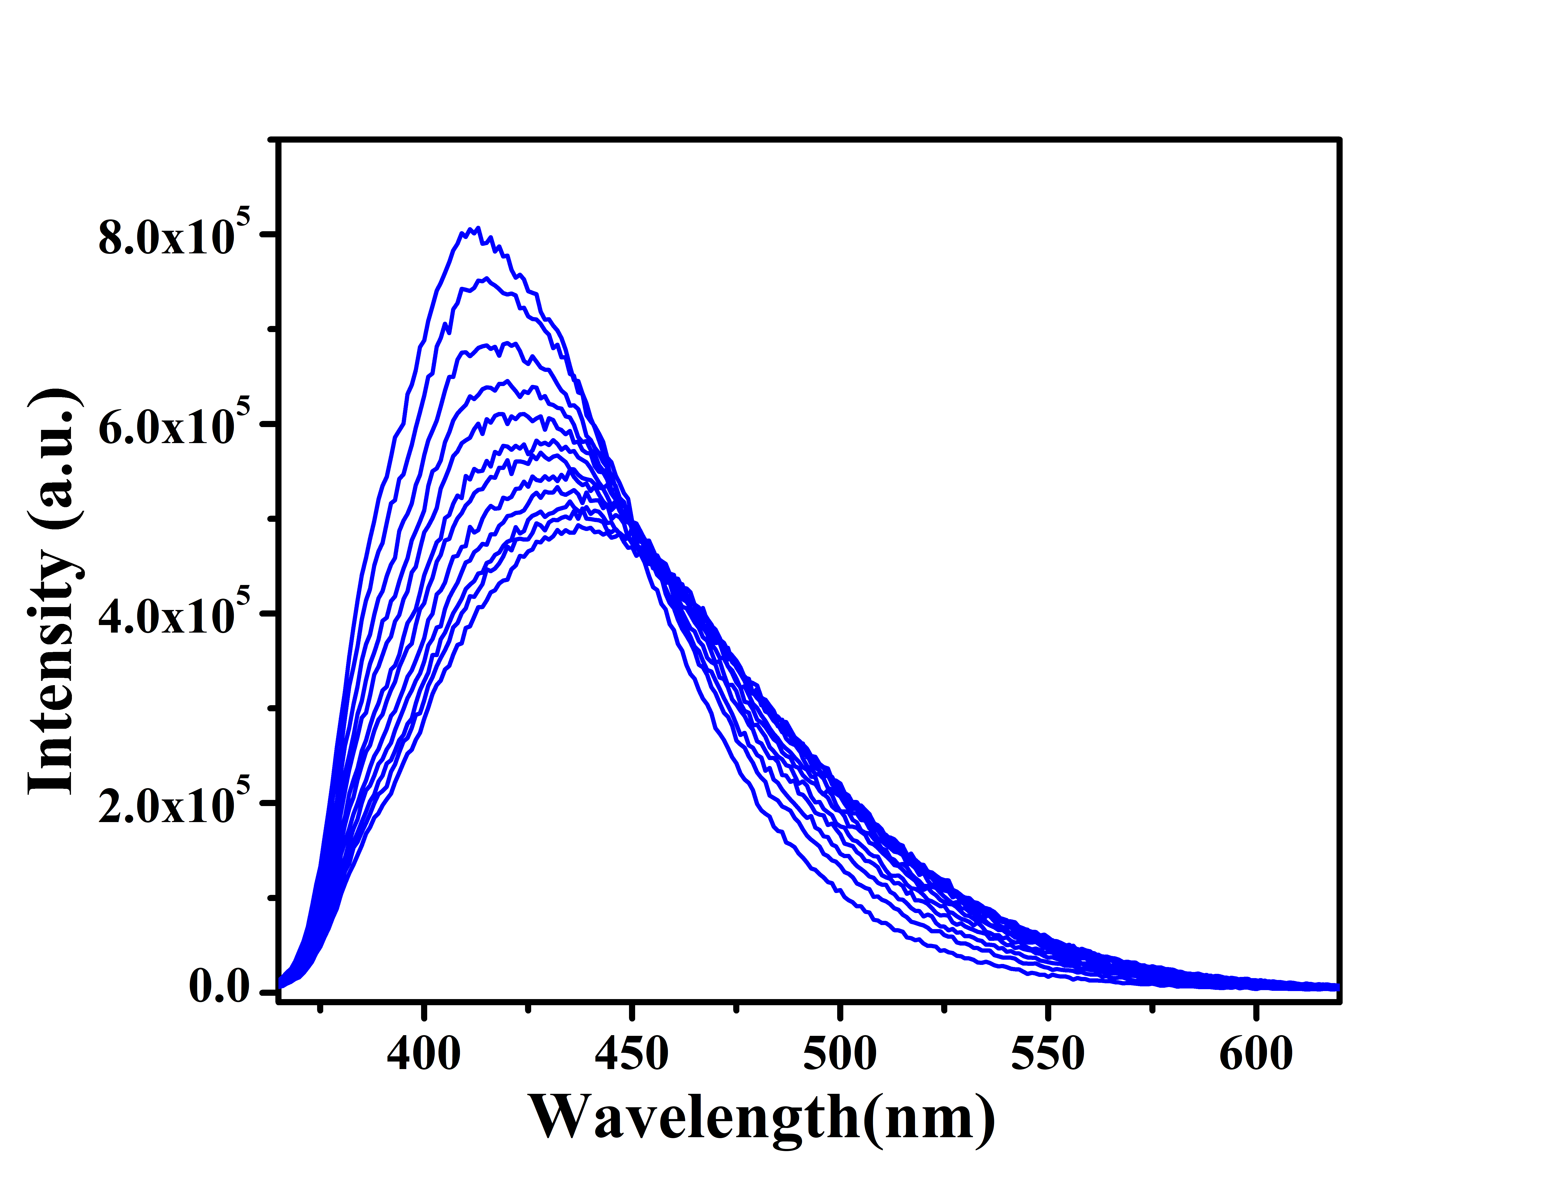

(a) (b)

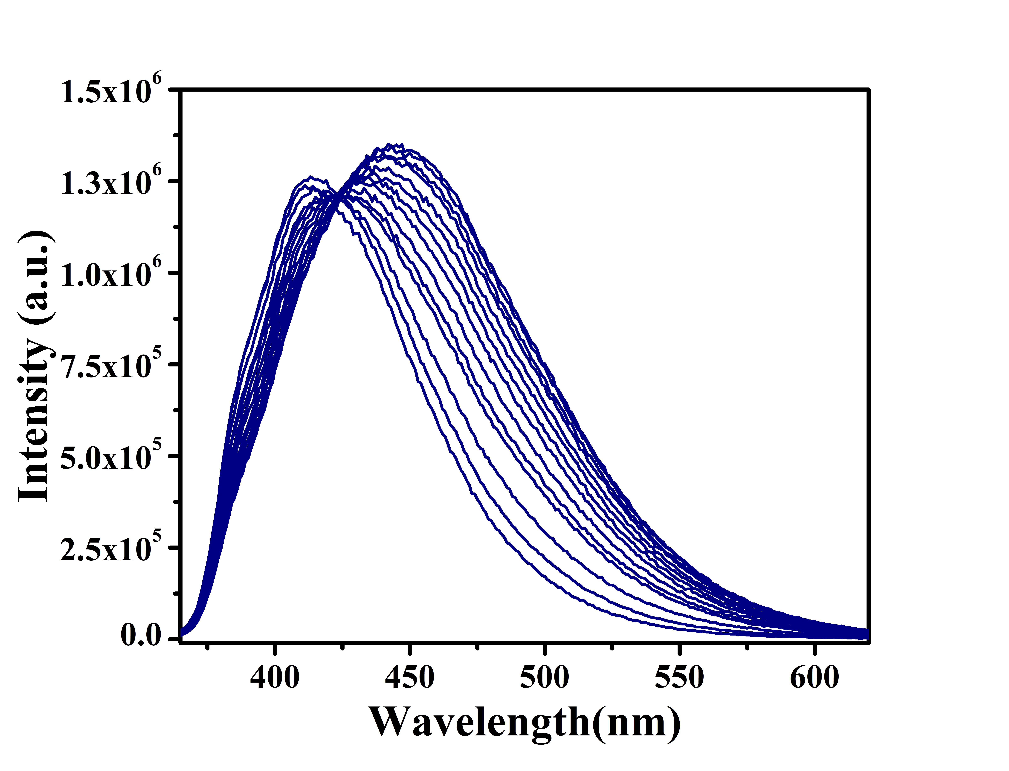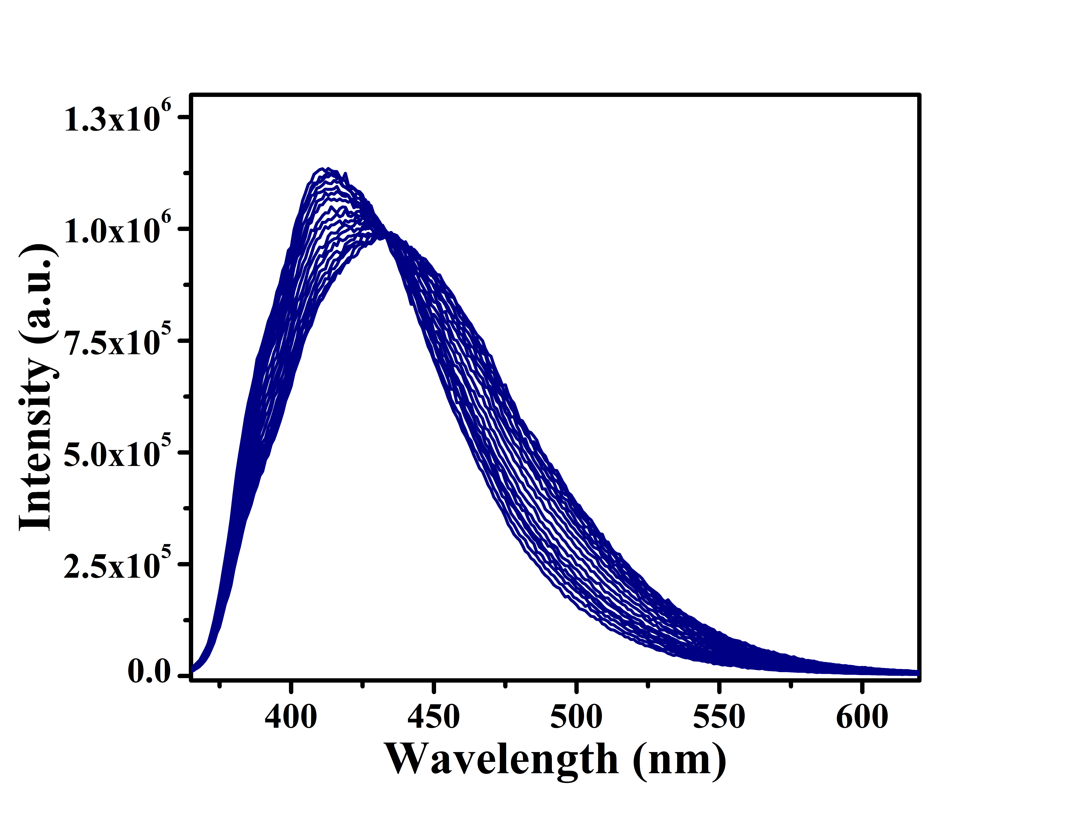

(c) (d)

**Figure 1:** Fluorescence titration of Ligand with Zn2+[(a) & (c)] andCd2+[(b) & (d)] in HEPES buffer/DMSO (1:1, *v/v*, pH=7.34, rt) and in Deionised water/DMSO (1:1, *v/v*, rt)